**Use Case Model**The use case model captures the requirements of a system. Use cases are a means of communicating with users and other stakeholders what the system is intended to do.

**Actors**A use case diagram shows the interaction between the system and entities external to the system. These external entities are referred to as actors. Actors represent roles which may include human users, external hardware or other systems. An actor is usually drawn as a named stick figure, or alternatively as a class rectangle with the «actor» keyword.

|  |  |
| --- | --- |
| http://www.sparxsystems.com/images/screenshots/uml2_tutorial/uc01.gif | http://www.sparxsystems.com/images/screenshots/uml2_tutorial/uc02.GIF |

Actors can generalize other actors as detailed in the following diagram:

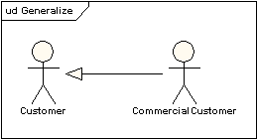

**Use Cases**  
A use case is a single unit of meaningful work. It provides a high-level view of behavior observable to someone or something outside the system. The notation for a use case is an ellipse.

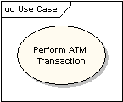

The notation for using a use case is a connecting line with an optional arrowhead showing the direction of control. The following diagram indicates that the actor "Customer" uses the "Withdraw" use case.

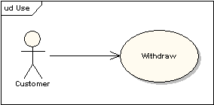

The uses connector can optionally have multiplicity values at each end, as in the following diagram, which shows a customer may only have one withdrawal session at a time, but a bank may have any number of customers making withdrawals concurrently.

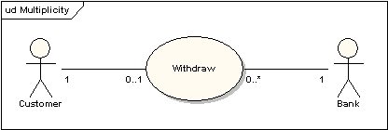

**Use Case Definition**  
A use case typically Includes:

* Name and description
* Requirements
* Constraints
* Scenarios
* Scenario diagrams
* Additional information.

**Name and Description**  
A use case is normally named as a verb-phrase and given a brief informal textual description.

**Requirements**  
The requirements define the formal functional requirements that a use case must supply to the end user. They correspond to the functional specifications found in structured methodologies. A requirement is a contract or promise that the use case will perform an action or provide some value to the system.

**Constraints**  
A constraint is a condition or restriction that a use case operates under and includes pre-, post- and invariant conditions. A precondition specifies the conditions that need to be met before the use case can proceed. A post-condition is used to document the change in conditions that must be true after the execution of the use case. An invariant condition specifies the conditions that are true throughout the execution of the use case.

**Scenarios**  
A Scenario is a formal description of the flow of events that occur during the execution of a use case instance. It defines the specific sequence of events between the system and the external actors. It is normally described in text and corresponds to the textual representation of the sequence diagram.

**Including Use Cases**  
Use cases may contain the functionality of another use case as part of their normal processing. In general it is assumed that any included use case will be called every time the basic path is run. An example of this is to have the execution of the use case <Card Identification> to be run as part of a use case <Withdraw>.  
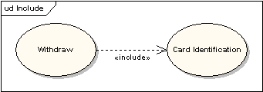

Use Cases may be included by one or more Use Case, helping to reduce the level of duplication of functionality by factoring out common behavior into Use Cases that are re-used many times.

**Extending Use Cases**  
One use case may be used to extend the behavior of another; this is typically used in exceptional circumstances. For example, if before modifying a particular type of customer order, a user must get approval from some higher authority, then the <Get Approval> use case may optionally extend the regular <Modify Order> use case.

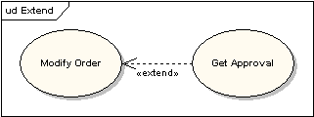

**Extension Points**  
The point at which an extending use case is added can be defined by means of an extension point.

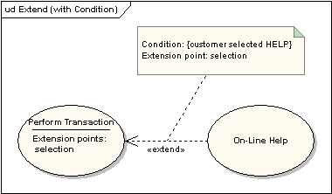

**System Boundary**  
It is usual to display use cases as being inside the system and actors as being outside the system.  
  
